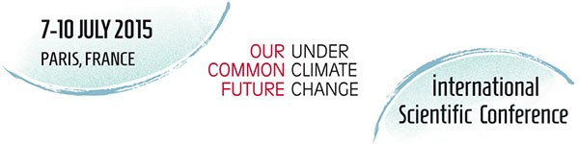

Institution’s address

Place, 15/10/2015

Re: Signature of the Outcome Statement – CFCC15

On behalf of (Name of Institution/International Research Program, City, Country), I have the pleasure to officially express our agreement and to sign the Outcome Statement of the International Scientific Conference ‘Our Common Future Under Climate Change’ which was organized at UNESCO and UPMC from 7-10 July 2015, in Paris.

Yours sincerely,

Signature of the Institution’s President/Director

(Name, Surname, Position, Institution)

*Attachment: Outcome Statement - CFCC15*